|  |
| --- |
| Black Swamp Bird observatory |
| Climate Change, Wind Energy, and Conservation |
| A Survey of Conflicting Issues |
|  |
| **Donald C. Bauman** |
| **3/23/2017** |

|  |
| --- |
|  |

**1. INTRODUCTION**

There is a multiplicity of program offerings by many groups which intend to contribute to the remediation and mitigation of climate change. This multiplicity brings into play a very real problem of its own: the lack of concerted and coordinated action among the groups. The actions and planning by these groups are neither on the same track, nor do they seem to share common goals. Some of these groups are the US Department of Energy, the US Fish & Wildlife Service, the American Wind Energy Association, the American Bird Conservancy, and the National Audubon Society to name just a very few. It is the purpose of this paper to bring together a “state of the art” description of the wind energy efforts, and to relate how they are often at odds with each other, particularly with respect to the conservation of habitat and wildlife species and the mitigation of climate change.

One approach to mitigate climate change is the transformation of the energy industry toward renewable energy generation of electricity, specifically going from traditional coal-fired generation to wind energy generation. There are a number of problems that have arisen from this course of action: (1) the lack of coordination among agencies and business groups responsible for siting, installing and operating wind farms; (2) the lack of public understanding of the consequences of installing a wind farm consisting of many turbines as compared to a small number of turbines; (3) the lack of environmental regulatory authority over the businesses installing wind farms; (4) a general lack of understanding of the true nature of the environmental impact of wind farms, both to humans and other species, particularly birds and bats; and (5) most fundamentally, the unabashed lack of environmental care or concern on the part of some wind farm businesses, as if somehow a wind farm were inherently good for the planet no matter what.

Taken together these problems have led to a disturbing trend among scientists of all sorts, from engineers to ornithologists, which is that they and their work become a mere marketing tool for the wind farm industry, subordinating science to concerns about public perception and industry growth. This is particularly true in the misuse of environmental impact assessments as tools to allow wind projects to proceed without due caution or concern for the environment and the species that reside there. Granted, some of the science involved in predicting the effect of wind farms on bird and bat species is imprecise at best; but in the last analysis we know one thing for sure: there are good places and bad places to put wind farms. Herein lies the crux of the dilemma. The wind industry, like all successful capitalist groups in a fairly uncontrolled business environment, sees unfettered growth as good in itself. Mitigating climate change does not require that kind of growth, however; it only requires enough growth in the wind industry to cover the increase in energy requirements of the growing world economies and replacement of energy produced by non-renewable sources, i.e. coal.

One of the effects of climate change, coupled with a growing world economy, has been the disappearance/displacement and extinction of various plants and animal species. Wind farms are specifically harmful to birds and bats, killing them by the hundreds of thousands here in the United States alone. One reason this is so unpalatable to us who are “conservationist” is that the killing is largely avoidable. There are simply places that wind farms should not be installed because they are too close to too many birds or bats. As an analogy: we can tell you it is not safe for your children to play in the street. We may not be able to tell you for certain that it is safe for them to play in the front yard instead because we haven’t any information about your front yard. We would have to get that information before allowing the children to play there. So it is with wind farms: we know they should not be placed in bird and bat migration routes, along sea shores or lake shores, near nesting areas, or in wintering spots. That’s where birds and bats congregate at different times of the year. We can’t tell you for sure whether there is a safe place for them nearby until after doing a scientific, rigorous environmental impact study for a proposed “front yard.”

What is to follow is a survey of conflicting issues in the wind industry from the perspective of conservationists concerned for the welfare of bird and bat species. It is a description of the current wind energy technology with the hope of illuminating the issues both sides are facing, and with the hope that a resolution to them may be developed intelligently. We conservationists refuse to relegate the lives of birds and bats to collateral damage when to do so is unjustified and so avoidable. If even a small fraction of the scientific rigor used to engineer the complex systems within wind turbines were applied to proper siting of turbines, this discussion would not be necessary. However, since the wind industry has avoided or been negligent of scientific integrity in their siting choices, we conservationists must defend the birds and bats and their role in sustaining the ecosystems of which they are an integral part.

2**. CLIMATE CHANGE BASICS**

Climate change and global warming are not the same. Global warming is the cause of climate change. Green House Gases (GHG) such as carbon dioxide are the cause of global warming. And, burning fossil fuels such as coal is a major cause of GHGs. Figure 1 shows the global warming that has taken place as the average temperature of the surface of the earth has risen, as measured since 1880 when we first started keeping good weather records. This global average rise in temperature - about 0.9oC, or 1.6oF - from pre-industrial levels to today’s seems small to us by comparison to daily temperature variations we are used to experiencing; yet, this really points to how delicate the climate balance is around the earth, where such a seemingly small elevation in average temperature is the cause of such major disruptions in climate as are already being experienced today: melting of polar ice caps, warming of the oceans, dying of coral reefs, drought, increasing severity of weather in microclimates, and more.

The United Nations Framework Convention on Climate Change (UNFCCC), at its meeting of 195 nations and the European Union in Paris in 2015, made resolutions to keep the rise in temperature well below 2oC, or 3.6oF, setting 1.5oC, or 2.7oF as an upper limit goal.1 This benchmark was set with the simple idea in mind that if global warming exceeds 2oC, the effects upon climate change and the climate change effects upon both humanity and other living species will be both intolerable and unavoidable.

The driving force behind global warming is the accumulation of GHG in the atmosphere. The most prevalent GHG is CO2; and CO2 is the direct result of burning fossil fuel such as coal, natural gas,

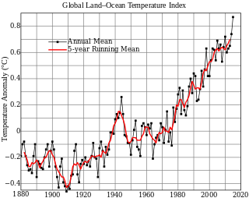

**Figure 1. Average Global Temperature Increases Since 1880.a**

**a** [**https://en.wikipedia.org/wiki/Global_warming**](https://en.wikipedia.org/wiki/Global_warming)**, last modified Jan. 31, 2017.**

and gasoline. In order to keep global warming to less than the 1.5oC benchmark it had been proposed that we must keep atmospheric CO2 below 400 ppm until at least the year 2030. The CO2 in the atmosphere reached 400 ppm in 2015, so we are already 15 years ahead of schedule toward failing to maintain less than a 1.5oC limit, and at the time this paper was being written it had reached 403 ppm (see Fig. 2 below). As a result, the IPCC has now recommended a goal of keeping the CO2 below 450 ppm by the year 2100;2 however, some climate change researchers believe this new benchmark is too high to avoid catastrophic consequences.

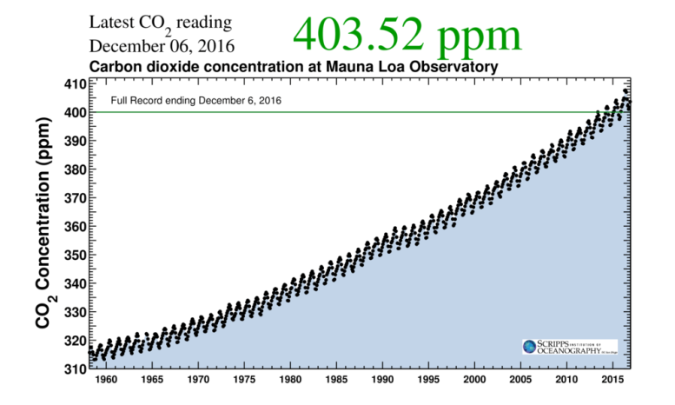

**Figure 2. Atmospheric CO2 Increase Since 1960.a**

**a** [**www.co2.earth**](http://www.co2.earth)**, Keeling curve, Scripps Oceanography.**

Figure 2 shows that the rate at which the CO2 level increases is rising faster than it has in the past. So there are two problems here: (1) we are not curtailing CO2, and (2) we are actually emitting more CO2 than ever before. In short, we are losing the battle to contain global warming and the resulting climate change. The effort to reduce GHG emissions by reducing fossil fuel consumption has failed so far.

**3. WIND ENERGY BASICS**

The process of converting wind into electricity is fundamentally a simple one: wind energy is captured by a propeller, the turning propeller spins a generator, the spinning generator produces direct current (DC), the direct current passes through an inverter which changes it to alternating current (AC), and finally the alternating current is let into the electrical grid from which we take our electricity.

From an engineering point of view there are many choices to be made along this process of energy generation. One such choice is: At what minimum wind speed should the turbine be designed to spin in order to generate electricity in a profitable way? To the engineer’s choice we conservationists add the rejoinder “At what minimum wind speed should the turbine be designed to spin in order to minimize bird and bat deaths?” This minimum speed is called the “cut-in” wind speed. Figure 3 is a representation of a typical power curve for a turbine, showing power generated as a result of wind speed driving the turbine. As it shows, the amount of power generated by the wind increases very rapidly from low speeds, say less than 3.5 m/s (7.8 mph), to more efficient speeds in the range of 14 m/s (31 mph). For more recent turbine designs the cut-in speed has been reduced to about 3.5 m/s (7.8 mph) to allow for additional power generation, even under low wind conditions. The issue here is that, for example, most bats will tend not to fly if the wind is over 6.5 m/s (14.5 mph), so in order to prevent most bat deaths a cut-in speed of 6.5 m/s should be used by the turbines, while for the energy generator, that means lost energy in the range from 3.5 to 6.5 m/s when the turbine is turned off. What does this mean to the generator? On an annual basis, if the cut-in speed were set to 5.0 m/s (11.2 mph) the power lost would be in the range of 0.3%, while the annual power lost would be 1.0% if the cut-in speed were set to 6.5 m/s. What does this mean for the bats? When set to an intermediate cut-in speed of 5.5 m/s (12.3 mph), the resulting bat deaths could be reduced by about 70% from that occurring at the 3.5m/s cut-in speed. At this cut-in speed the estimated annual power lost to the generator would be 0.6%.3 So far, the wind industry has found this higher cut-in speed to be unacceptable, just as we conservationists find the avoidable killing of birds and bats to be unacceptable.

Because the power curve for the generation of energy is so steep with respect to wind velocity, the siting of wind farms becomes another choice in the process of generation. Simply put, more wind

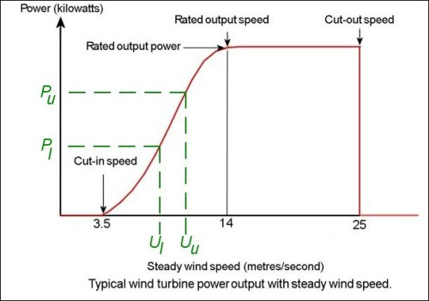

**Figure 3. Typical Power Curve for a Wind Turbine.a**

**a** [**www.wind-power-program.com/turbine_characteristics.htm**](http://www.wind-power-program.com/turbine_characteristics.htm)**, p. 15, “Wind speed and power output statistics.**

means more power generation. The question then is “Where should the wind farm be placed in order to generate power in a maximum, profitable way?” To which we conservationists respond “Where should they not be placed so as to avoid endangering bird and bat species?” As it turns out these are difficult questions, because many of the areas that offer high average wind velocities are also good habitat for birds and bats. In Figure 4 below we can see the distribution of high wind areas in the Ohio and Western Lake Erie Basin area as they are available to a turbine having a hub height of 100 m (328 ft).

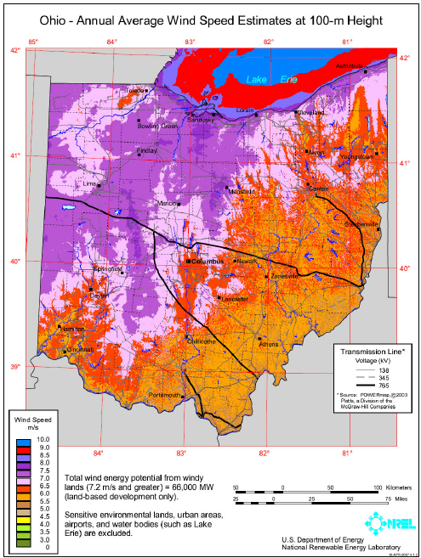

**Figure 4. Wind Energy Map for Ohio and Western Lake Erie.**

In Figure 5 we see Ohio areas which have been used for industrial sized wind farms. It is clear by comparing Figs. 4 and 5 that the siting rationale so far has been primarily based upon availability of wind, though there seems to be an apparent reluctance to build on the shores of Lake Erie.

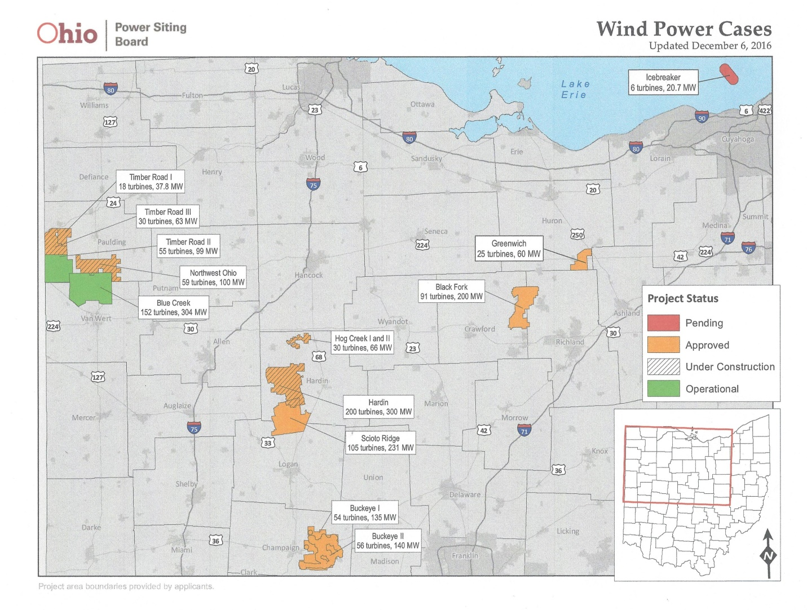

**Figure 5. Industrial-sized Wind Farm Sites in Ohio.**

This reluctance is changing, however, with the moving forward of the Icebreaker project off the shore of Cleveland. The initial project definition is to place 6 turbines in the waters of Lake Erie about 8 miles from shore. It is clear from Fig. 4 that the off-shore site chosen is ideal if the only consideration is available wind. However, not enough is known about the potential impact of wind farms when they are placed in open waters. In fact, so little is known that on the Canadian shore of Lake Erie, where over 1,250 turbines were being planned for installation, the Ontario government in February 2011 stopped all projects.4 There are currently no off-shore wind projects on the books in Ontario, pending further scientific study of the potential negative impacts upon wildlife and the lake itself. The Ohio government is apparently not as judicious as the Ontario government in this case.

One of the big issues facing increased use of either solar or wind energy generation comes from the fact that energy is not being generated consistently during the 24-hour day; rather it is generated when the wind blows or the sun shines. If wind energy is generated in large quantities there simply may be nowhere in the grid to put it. The grid is base-loaded with energy from other sources, such as coal, natural gas, and nuclear, which are provided to the grid on a constant basis. Peak supplies from wind at the wrong time of day could be an overload, but shutting down baseload plants to balance out the power supply is not an option. Likewise, if the wind energy is not forthcoming during a peak energy consumption period, then again the issue of inconsistent supply arises. Solutions to this dilemma are being investigated: extensive battery storage as being proposed by Tesla Motors; or variable power pricing to encourage consumer usage during peak energy production times; or a smart grid system to better regulate the incoming power generated; but as of now none of these solutions are feasible.

It seems to be a common misperception that wind energy can mitigate climate change because turbines do not emit greenhouse gases, specifically CO2. This is partly wrong for two reasons. First, CO2 emissions were incurred during the manufacture of the turbine, creating a so-called carbon debt. This debt has been estimated to be approximately 1,200 tons CO2 for a 2 MW turbine.5,6 This figure includes the manufacture of materials for the turbine, steel and concrete, but not the transportation and installation of the completed turbine which would also add to the turbine’s total carbon debt. Second, operating the turbines does not eliminate any CO2 emissions, they simply don’t add to them. The only way turbines could reduce CO2 emissions would be if they allowed for the shutdown of a fossil-fuel burning power plant. In the overall scheme of mitigating climate change, it is the shutting down of fossil-fuel plants that must be accomplished. Failing to add to the emissions isn’t enough, the total emissions must be reduced significantly in order for any true mitigation to be successful.

**4. WIND ENERGY TODAY – 2016**

In order to get a better grasp of the magnitude of the wind industry it is worthwhile summarizing the extent to which wind farms already exist in the United States as a whole, and the specific projects being planned for development in the State of Ohio. This paper will go into a fair amount of detail in the case of Ohio because it is a very sensitive area from the standpoint of bird and bat migration, and thus has the potential for resulting high mortality due to turbine strikes.

The American Wind Energy Association provides data shown in Table 1 on the number of turbines already existing on a state-by-state basis. We will summarize the top 15 states so as to show Ohio’s place in the overall scheme of things, as well as the totals for all 50 state combined; ranking based on total capacity (MW).

As is clear from Table 1, wind energy development in Ohio lags far behind that of other states in terms of providing a portion of the state’s energy requirements. However, perhaps that is as it should be given Ohio’s vast shoreline resources critical to numerous protected bird and bat species. If wind energy is to provide a safe and sustaining form of renewable energy it must consider the potential damage to the environment and to the species that live there. Additionally, while this consideration is an Ohio Power Siting Board filing requirement for a proposed wind project, there seems to be a general disdain for adequate ecological studies since the pre-construction animal surveys have been poorly done, and the post-construction mortality data are being hidden from public view by the courts.

Table 1. Wind Energy Existing in USA as of 3Q 2016.a

|  |  |  |  |  |
| --- | --- | --- | --- | --- |
|  |  |  | **Total** | **In-State** |
|  |  | **Number of** | **Capacity** | **Energy** |
| **Rank** | **State** | **Turbines** | **(MW)** | **(%)** |
| 1 | Texas | 10,751 | 18,531 | 12.1 |
| 2 | Iowa | 3,719 | 6,365 | 35.8 |
| 3 | California | 8,413 | 5,662 | 6.7 |
| 4 | Oklahoma | 2,915 | **o**5,453 | 23.3 |
| 5 | Illinois | 2,348 | 3,842 | 6.0 |
| 6 | Kansas | 2,178 | 3,836 | 27.7 |
| 7 | Minnesota | 2,357 | 3,435 | 17.4 |
| 8 | Oregon | 1,843 | 3,163 | 12.2 |
| 9 | Washington | 1,725 | 3,075 | 7.1 |
| 10 | Colorado | 1,879 | 2,965 | 16.0 |
| 11 | North Dakota | 1,177 | 2,143 | 19.8 |
| 12 | Indiana | 1,096 | 1,895 | 5.1 |
| 13 | New York | 1,014 | 1,749 | 2.8 |
| 14 | Michigan | 887 | 1,531 | 4.1 |
| 15 | Wyoming | 960 | 1,410 | 9.1 |
| … |  |  |  |  |
| 26 | Ohio | 254 | 444 | 1.1 |
|  |  |  |  |  |
| Total | US+Guam+Puerto Rico | 49,000 | 75,716 |  |
|  |  |  |  |  |

**a American Wind Energy Association,** [**www.awea.org**](http://www.awea.org)**, viewed Feb. 1, 2017.**

Table 2 summarizes the state of the wind industry development in Ohio, both existing and planned. These data are based on information from the Ohio Power Siting Board, and pertains to wind farms of 5 MW capacity or more. It is important to note that virtually all these projects are located in northwest Ohio alone and are not spread out across the entire state.

Thus the concrete plans as we know them for Ohio call for an increase from 207 wind turbines to 968 wind turbines in the near future. But, aside from the increase in the number of turbines in the context of poorly regulated siting requirements, there is the appearance of a project, (i.e.,Icebreaker), for the siting of offshore turbines in Lake Erie, off the coast of Cleveland. At present there are no offshore turbines on Lake Erie, or in any fresh water lake in the world.

We should remember that the Ontario government in 2011 cancelled all proposed off-shore wind energy projects (totaling approximately 1,250 wind turbines) on the justification that the science to prepare and evaluate an off-shore environmental impact study was too immature, and therefore incapable of fulfilling its purpose.

**Table 2. Wind Energy in Ohio (Ohio Power Siting Board) in 2016.a**

|  |  |  |  |  |
| --- | --- | --- | --- | --- |
| **Project** |  |  | **Number of** | **Capacity** |
| **Name** | **County** | **Status** | **Turbines** | **(MW)** |
| Blue Creek | Paulding, Van Wert | Operational | 152 | 304 |
| Timber Road II | Paulding | Operational | 55 | 99 |
|  | **Operational Subtotal** |  | **207** | **403** |
| Buckeye I | Champaign | Approved | 54 | 135 |
| Hog Creek I | Hardin | Approved | 30 | 66 |
| Hardin | Hardin | Approved | 200 | 300 |
| Timber Road I | Paulding | Approved | 18 | 38 |
| Timber Road III | Paulding | Approved | 30 | 63 |
| Black Fork | Crawford, Richland | Approved | 91 | 200 |
| Buckeye II | Champaign | Approved | 56 | 140 |
| Northwest Ohio | Paulding | Approved | 59 | 100 |
| Greenwich | Huron | Approved | 25 | 60 |
| Scioto Ridge | Hardin, Logan | Approved | 105 | 231 |
|  | **Approved Subtotal** |  | **668** | **1,333** |
| Seneca Wind Farm | Seneca | Pre-application | 87 | 200 |
| Icebreaker | Lake Erie (offshore) | Pre-application | 6 | 21 |
|  | **Pre-application Subtotal** | | **93** | **221** |
|  |  |  |  |  |
|  | **Grand Total** |  | **968** | **1,957** |

**a Ohio Power Siting Board,** [**www.opsb.ohio.gov**](http://www.opsb.ohio.gov)**, viewed Jan. 18, 2017.**

That is still largely the case; however, there are some pertinent facts which would tend to tell us not to proceed with off-shore wind on Lake Erie. We know that there are bird species that migrate across the lake. Some of these are protected species such as the Kirtland’s Warbler, of which there are only a few thousand breeding pairs remaining. There are other avian species which as part of their migration cycle spend winter months in the open waters of the lake. We know that roughly 10% of the world’s population of Red-breasted Mergansers may spend November and December off the shores of Cleveland at a distance of between 2 and 8 miles, where the Icebreaker turbines are planned to be installed. And perhaps most urgently, there is the issue of proof of compliance, where the wind energy companies are compelled to show, by using post-construction mortality studies, that they are not in violation of the Migratory Bird Treaty Act or the Endangered Species Act: to date, there is no known, rigorous way to perform such studies - the protocols have not yet been developed and verified for off-shore turbine installations. So, proof of compliance is impossible.

In addition to our concerns for birds, there is justifiable concern over the potential implications of the Icebreaker project. While they recently have stated that the project is for 6 turbines, others, including the Ontario Ministry of Natural Resources, are treating this project as a go/no-go pilot project for putting many more turbines on the Great Lakes, not just Lake Erie. Icebreaker, as a pilot project, is starting small with the potential to get big. That approach has been the openly stated policy for first-ever off-shore wind development in Long Island Sound, where the first small project currently is being operated near Block Island, Rhode Island. Jeff Grybowski, CEO of Deepwater Wind, the developer of the 5 turbine, 30 MW wind farm 3 miles beyond Block Island was quoted by Forbes7 as saying “If you try to start with one large project, a la Cape Wind, a lot of things can go wrong. When you scale it down it’s less scary for everyone.” It is worth noting that the Cape Wind project, a proposed 130 turbine project, was cancelled when the utilities set to purchase the power generated had pulled out of the agreement after lengthy court battles with conservationists, Native Americans, fishermen, and wealthy landowners nearby.

As far as on-shore wind farms are concerned, we have some small amount of data which shows the possible extent to which these projects are killing birds and bats, and whether there are any endangered species involved. These data are the result of wind energy companies performing post-construction mortality surveys in order to quantify and identify bird and bat mortality by species and location. While these studies leave something to be desired from the standpoint of scientific rigor and integrity, they are at least a starting point. It is worth noting here, before presenting the data that is available, that some of the wind energy companies have taken to the courts to prevent the data from becoming public on the justification that there is proprietary information at stake that should remain a trade secret. However, it would seem logical that if the turbines were not killing large numbers of birds and bats the wind energy companies would want to shout it from the rooftops, not keep it secret.

Data from the Blue Creek Wind Farm in Paulding County, Ohio, where the USF&W draft report of the Midwest Wind Energy – Multi-Species Habitat Conservation Plan states in Table 4.8 that a total of 725 and 850 bat carcasses were found during two studies at the Blue Creek facility, in 2013 and 2012, respectively. These bat mortality rates are the first and fourth largest of the 44 studies cited in the report.

At the risk of becoming too technical for the scope of this paper, it seems worthwhile to consider the issues associated with the post-construction monitoring of bird and bat turbine-induced mortality, and the errors that seem to be deeply hidden in the data that are being reported. The protocols for detecting carcasses of birds or bats that have been killed by turbines in operation involve a fairly small number of search variables: the size of the search area underneath the turbine, the condition of the search area vegetation, the effectiveness of the searchers, the frequency of the searches, the possible removal of carcasses by scavengers between searches. For the owners of the wind farms, these variables are sampling variables and have a direct effect upon the cost of the surveys. For example, do you survey all the turbines or just some of them; do you survey them every day or every week; do you clear the area underneath the turbines of vegetation to improve the search efficiency; do you extend the search out to a radius of 50m, 100m, or 150m? The purpose behind specifying these variables in clearly defined terms is to facilitate corrections to the actual carcass counts that result from the surveys. An easy example is that if it is decided to search only half the turbines then the resulting carcass count needs to be doubled to account for the mortality for the total number of turbines. Similarly, each of the variables can be used to correct the actual count to arrive at an estimate for the total mortality. As it turns out, there is usually a large correction involved in getting from actual survey results to estimated total mortality, which makes it important that any survey results reported specify the search variables used during the survey. Anything less than full disclosure perverts the science of peer review, which is a major portion of the post-construction survey intent.

Let us take a look at a post-construction mortality survey report published August 4, 2011, by the consulting firm of Natural Resource Solutions, Inc. (NRSI) on behalf of the Harrow Wind Farm owner, International Power Canada, Inc.8 The Harrow Wind Farm is located in Essex, Ontario, on the north shore of western Lake Erie, almost due north of Magee Marsh, Oak Harbor, Ohio. It consists of 24 wind turbines having a total capacity of 39.6 MW. Construction was completed and operation began in 2010.

The Summary and Results section of the report states the annual mortality rates found for birds and bats, and in the case of bats compares that mortality number to the Ontario Ministry of Natural Resources threshold guideline, which are arranged in matrix format in Table 3 below. For the sake of additional information the OMNR Threshold Guidelines for bird mortality have been added, even though they were issued in December 2011, after the Harrow Farm report was written.

|  |  |  |  |
| --- | --- | --- | --- |
| **Table 3. Harrow Farm Mortality Result Summary 2010** | | | |
|  |  |  |  |
|  |  | Reported | OMNR |
|  |  | Annual | Threshold |
|  |  | Mortality | Guidelines |
| Avian: | birds/turbine/yr | 2.73 | 14.00a |
|  | birds/MW/yr | 1.66 | N/A |
|  |  |  |  |
| Bats: | bats/turbine/yr | 18.36 | 10.00b |
|  | bats/MW/yr | 11.13 | 4.50 |

**a Birds and Bird Habitats: Guidelines for Wind Power Projects, sect.4.1, Ontario Ministry of Natural Resources, December 2011, available at** [**http://www.mnr.gov.ca/en/Business/Renewables/index.html**](http://www.mnr.gov.ca/en/Business/Renewables/index.html)**.**

**b Bats and Bat Habitats: Guidelines for Wind Power Projects, sect.4.1, Ontario Ministry of Natural Resources, July 2011, available at** [**http://www.mnr.gov.ca/en/Business/Renewables/index.html**](http://www.mnr.gov.ca/en/Business/Renewables/index.html)**.**

One would think that these results for bat mortality alone would be enough to warrant some recommendations for mitigating action, but the report merely states the following:

“Although 2010 mortality monitoring at the Harrow Wind Farm has resulted in a bat mortality rate within the mid-range of estimated North American mortality rates, the bat mortality rate at the Harrow Wind Farm is above the threshold of 10 bats/turbine/year or 4.5 bats/MW established by the MNR in 2010 for “potential negative environmental effects” (OMNR 2010).”9

There were no recommendations made as a result of the bat mortality data, as if by ignoring them they would go unnoticed.

Moreover, upon closer examination there are two errors earlier in NRSI’s report which are worthwhile considering when attempting to use the report for conservation purposes.

The first error appears on p. 24 of the report where NRSI summarized their bird mortality data by adding up the corrected mortality per turbine for the 4 month study period, then mistakenly expressed that sum as “total annual mortality.” The corrected annual mortality should be 3 times their stated value. The same error was made on page 34 in expressing the bat mortality, which should also be 3 times their expressed value. Therefore, the avian mortality number increases to 8.19 birds/turbine/yr, or 4.98 birds/MW/yr; and the bat mortality increases to 55.08 bats/turbine/yr, or 33.39 bats/MW/yr.

The second error involves the equation used to estimate corrected mortality on p.22. It is inadequate since it does not allow for any correction when no carcasses are found. The instances of no carcasses found are the large majority of the instances, about 95%, for which no mortality can be estimated. This is clearly inadequate, since during their searcher efficiency studies the searchers found no carcasses about 40% of the time when as many as 3 carcasses had been placed there for them to find.

This merely points to the lack of scientific rigor in the analysis of the data as a whole, and begs the issue of the study’s validity and usefulness. At a minimum it underestimates the true nature of mortality; and more realistically, it obscures the potential danger to the existence of endangered or threatened species.

**5. WIND ENERGY PROJECTIONS FROM VARIOUS SOURCES**

Each of the major entities responsible in some way for the progress and implementation of wind energy has its own projections about the scope of the wind energy industry in the future. They may or may not share a common mandate for the future, such as, for example, a Renewables Portfolio Standard (RPS), such as have been drawn up by only 29 of the 50 states. They may or may not contribute to the future projections of other agencies, as the American Wind Energy Association (AWEA) has done often. But in the end what is apparent is that the future projections are only somewhat similar, and bear little likeness to the projections found in “The Climate Crisis and Its Solution,” by Robert B. Fraser, which was largely informed by the work of the Intergovernmental Panel on Climate Change (IPCC).

Projections put forth by Fraser are intended to fulfill the requirements of the IPCC to limit GHG emissions in order to slow down the effects of climate change and avoid catastrophic human consequences. In contrast, projections put forth by AWEA are intended to maximize wind industry development. From the perspective of we conservationists, this has far too little regard for the consequences to the environment and the species which live there. Falling between these two extremes are some governmental agencies, for example, which have seemingly competing obligations, for example, to fulfill the responsibilities imposed by such federal mandates as the “Responsibilities of Federal Agencies to Protect Migratory Birds”10 and the “20% Wind Energy by 2030.”11 The goals of the IPCC and the AWEA are clear and focused, but this does not appear to be the case for the governmental agencies.

As a result of this lack of focus on the part of governmental agencies, the task of protecting the environment and the species within it has been hindered because recommendations made by the government upon the wind industry with regard to birds and bat survival have been voluntary, and thus not been enforceable in a court of law. The consequence of this lack of legally enforceable requirements has been that the wind industry does not take their environmental obligations seriously enough to commit sufficient action or money to adhere to them. It is true that the requirements do mandate an Environmental Assessment (EA) by the party proposing a new wind project; but the scrutiny of the EA by the US Fish & Wildlife Service is largely ignored, so the studies behind the EA have been lacking scientific rigor and/or integrity, and the USFWS is helpless to take any punitive action. The same is true of post-construction mortality surveys intended to quantify bird and bat mortality arising from turbines in operation: the search protocols and the mathematics behind them are badly lacking both integrity and rigor, and as a result they underestimate the true quantity of mortality.

Further, this lack of governmental focus has set a precedent for the formation of a new kind of consulting firm, one willing to misrepresent the environmental impact data, or to collect only those data which are in the interest of their clients, namely, those wishing to begin a wind project. The EA has become a farce of a document in too many cases, merely a box to be checked off in the list of things required to gain permission to begin a wind project.

The data in Table 3 below was compiled from a number of sources in an attempt to show the differing wind energy projections over the next 35 years, thru 2050. The year 2050 is a target year for the IPCC climate goals, and is treated by them as a watershed year: either we will have turned the corner in reducing GHG emissions, or we will be well on our way to irrevocable climate change and having made the planet uninhabitable. It seems clear from the disparity in the forecasts, and the lack of conformity among them that there is no true consensus of planning for the future with respect to wind energy development.

While this lack of consensus is worrisome enough simply from the standpoint of meeting our climate goals of lower GHG emissions, it is also worrisome from the standpoint of the survival of bird and bat species. Each of these plans has its own form of attack upon the environment, each with a different degree of severity, and will require a different degree of mitigation efforts. Without having some reasonable consensus the response to potentially diminishing biodiversity and the extinction of species is made more difficult.



**6. CONCLUDING REMARKS**

Overall, the relationship between the wind industry and the various nongovernmental conservation groups is a rather contentious one. As has been presented above there are many conflicting interests which seem to have no resolution forthcoming any time soon; but there is a simple fact which pervades the situation: the wind industry is backed by huge amounts of money attracted by the promise to make more, while the local, state, and federal regulations meant to protect the environment and the species within it are particularly toothless to do their job. It is in this atmosphere that the conservation groups have inserted themselves for the sole purpose of doing what the regulatory agencies are not: protecting birds and bats from mortal harm at the hands of the wind industry.

Behind all the arguments to preserve birds and bats from harm is the usually unspoken idea that somehow birds and bats matter. And while this idea has many facets, whether they are aesthetic, economic, social, recreational, agricultural, or ecological, birds and bats continue to matter. The Migratory Bird Treaty Act of 1918 may not have specifically said why birds should be protected, but clearly their protection was the intent of the act and the reason for its being enacted. The same is true of the Bald and Golden Eagle Protection Act: its intent is to protect the lives of individual birds. It should be clearly noted that these acts were not about the preservation of bird species as a whole, although that may be a result of the act; but rather, are for the preservation of individual birds. Therefore, it is wholly inappropriate for anyone to be talking about allowing a certain, specified amount of birds or bats to be killed as collateral damage, so to speak, as long as the overall species survives somewhere else. But this is exactly the reasoning behind the USFWS Midwest Wind Energy Multi-Species Habitat Conservation Plan. Again, it is in this atmosphere that the conservation groups have inserted themselves for the sole purpose of doing what the regulatory agencies are not: protecting birds and bats from mortal harm at the hands of the wind industry.

What has followed from this conflict between the wind industry and the conservation groups is a polarizing of views into two opposed camps: capitalism versus conservation. While there seems to be no middle ground for discussion, that should not have to be the case. We are not looking for a middle ground in which to compromise; rather, we are looking for a middle ground from which to proceed to do the right thing for the environment and those who live there: that common idea from which both sides of the argument can proceed in concert. Ostensibly, the middle ground is the intent to mitigate climate change. We do, after all, need wind energy as one of the renewable energy sources to eliminate the burning of fossil fuels. The issue is then “How much wind energy do we need?” since of all the ways to mitigate climate change it is potentially the most actively destructive of the ecology (birds and bats). With the overall idea in mind that wind energy is necessary in some degree, we conservationists ask the wind industry for the following:

1. Use rigorous science to perform environmental assessments of prospective wind farm sites.
2. Be willing to cancel the project if it shows likelihood of violating the MBTA or the BGEPA.
3. State honestly, and up front, the intended scope of the development project.
4. State honestly, and up front, what mitigating steps are to be taken should the project be operational but the MBTA and/or the BGEPA be violated unexpectedly.
5. Perform rigorous scientific post-construction mortality surveys to monitor the effect of the project on bird and bat life, and compare it to the expectations put forth by the preconstruction environmental assessment.
6. Publish the data and results of the post-construction mortality monitoring surveys on a periodic basis, and open them to scientific peer review in a concerted effort to improve the science behind the surveys, and to make those improvements available to all.
7. If it turns out that the site was poorly chosen after all, that bird and bat mortality expectations were wrong or have changed, or that changing patterns of bird and bat migration, nesting, etc., have changed, then be willing to turn off the turbines and take them down.
8. Continue to develop wind technology not only to increase power output, but simultaneously to lower mortality risk to birds and bats.

With the overall idea in mind that wind energy is necessary in some degree, we conservationists ask the local, state, and federal regulators and legislators for the following:

1. Designate a local authority, be it municipal or county, with the responsibility and authority to approve or deny licensing of wind farm sites, and to rescind or suspend such licenses should the sites violate the terms of the license and/or applicable laws.
2. Provide a mandate that existing environmental laws be a primary concern in the licensing process, and provide expertise to the authority to allow it to fulfill that obligation.
3. Mandate that the USEPA, the USFWS, the states’ “DNR,” the states’ “EPA,” have the authority and obligation to prosecute violations on corporate and personal levels, even to the extent of suspending or revoking licenses to operate.
4. Develop an energy generation policy for wind energy that is consistent with the goals of both climate change mitigation as outlined in the Paris 2015 UNFCCC Agreement, and bird protection as in the Executive Order 13186 on the “Responsibilities of Federal Agencies to Protect Migratory Birds.”

Lastly, it should be kept in mind that these are but temporary goals. As the science and technology of wind energy and environmental science continue to improve, and as the demands for climate change mitigation increase, the goals will change, and will likely seem more drastic. And further, the scope of the cooperation will become more extensive because it will necessarily involve multiple nations who share a common interest in the health and life of the migratory birds which they share and upon which their interrelated national ecosystems depend.

**7. ENDNOTES**

1 United Nations Framework Convention on Climate Change, 21st Session, Paris, 30 November to 11 December 2015, (issued 12 December 2015), Section II, para. 17.

2 Robert B. Fraser, The Climate Crisis and its Solution: An Energy Transformation, p. 19, available free as a pdf at [www.climateandenergyreport.org](http://www.climateandenergyreport.org).

3 Manuela M. P. Huso, John P. Hayes, Effectiveness of Changing Wind Turbine Cut-in Speed to Reduce Bat Fatalities at Wind Farms, an annual report prepared for the Bats and Wind Energy Cooperative and the Pennsylvania Game Commission, p. 3, May 2010, available at [www.batsandwind.org/pdf/Curtailment Final Report 5-15-10 v2.pdf](http://www.batsandwind.org/pdf/Curtailment%20Final%20Report%205-15-10%20v2.pdf).

4 [www.ontario-wind-turbines.org/owt-maps-c19.html](http://www.ontario-wind-turbines.org/owt-maps-c19.html) displays a map of the proposed wind projects before the moratorium that went into effect in 2011. The Wasatch project alone planned for about 10,000 MW.

5 How Much CO2 Gets Emitted to Build a Wind Turbine?, August 16, 2014, available at [www.stopthesethings.com/2014/08/16/how-much-co2-gets-emitted-to-build-a-wind-turbine](http://www.stopthesethings.com/2014/08/16/how-much-co2-gets-emitted-to-build-a-wind-turbine).

6 Timothy Maloney, a critique of The Solutions Project, section 4, Material Use and Manufacturing Emissions – Onshore Wind, available at [www.timothymaloney.net/Critique_of_100_WWS_Plan.html](http://www.timothymaloney.net/Critique_of_100_WWS_Plan.html).

7 Christopher Helman, Is America’s First Offshore Wind Farm A Real Revolution Or Just Another Green Boondoggle?, Forbes, May 10, 2016.

8 Harrow Wind Farm, 2010 Post-construction Monitoring Report, Natural Resource Solutions Inc., August 2011, available at [www.ontario-wind-resistance.org/wp-content/uploads/2011/09/nrsi_0953c_harrow-2010-post-construction-report_2011_08_04.pdf](http://www.ontario-wind-resistance.org/wp-content/uploads/2011/09/nrsi_0953c_harrow-2010-post-construction-report_2011_08_04.pdf).

9 ibid., p. 37.

10 Executive Order 13186, January 10, 2001, found at [www.energy.gov](http://www.energy.gov).

11 20% Wind Energy by 2030, Increasing Wind Energy’s Contribution to U.S. Electricity Supply, U.S. Department of Energy, National Renewable Energy Laboratory, July 2008, available at [www.energy.gov](http://www.energy.gov).

**8. LIST OF COMMONLY OCCURING ACRONYMS**

ABC American Bird Conservancy

AWEA American Wind Energy Association

AWWI American Wind Wildlife Institute

BGEPA Bald and Golden Eagle Protection Act

BSBO Black Swamp Bird Observatory

DNR Department of Natural Resources

DOE Department Of Energy (US)

EA Environmental Assessment

EIA Energy Information Administration

EIS Environmental Impact Statement

EoA Evidence of Absence

EPA Environmental Protection Agency

ESA Endangered Species Act

HCP Habitat Conservation Plan

IEA International Energy Agency

IPCC Intergovernmental Panel on Climate Change (United Nations)

ITP Incidental Take Permit

MBTA Migratory Bird Treaty Act

MWE Midwest Wind Energy Multispecies Habitat Conservation Plan

NEPA National Environmental Policy Act

NREL National Renewable Energy Laboratory

NSRI Natural Resource Solutions, Inc.

OMNR Ontario Ministry of Natural Resources

OPSB Ohio Power Siting Board

OWR Ontario Wind Resistance

RPS Renewables Portfolio Standard

USFWS US Fish & Wildlife Service

USGS US Geological Survey

**9. BIBLIOGRAPGHY OF USEFUL RESOUCES FOR FURTHER READING**

Fraser, Robert B., *The Climate Crisis and Its Solution: An Energy Transformation*, 2015, available free as a pdf at [www.climateandenergyreport.org](http://www.climateandenergyreport.org).

Klein, Naomi, *This Changes Everything*, *Capitalism vs. The Climate*, Simon & Schuster, 2014

Emmanuel, Kerry, *What We Know About Climate Change*, The MIT Press, 2nd Edition, 2012

Thich Nhat Hanh, *Love Letter to the Earth*, Parallax Press, 2013

**10. LIST OF USEFUL WEBSITES**

[www.awea.org](http://www.awea.org) – American Wind Energy Association; an industry/technical society for the promotion of the wind energy industry as a whole.

[www.awwi.org](http://www.awwi.org) – Find the Summary Report “Wind Turbine Interactions with Wildlife and their Habitats, January 2014.”

[www.bsc.org/birdmon/wind/resources.jsp?=reports](http://www.bsc.org/birdmon/wind/resources.jsp?=reports) – Find the “Wind Energy Bird and Bat Monitoring Database – Project resources,” a database of information on bird and bat mortality at wind farms I Canada, 2012, 2014, and 2016. Of special interest are the reports from wind farms in Ontario. The site is run by Bird Studies Canada and is called “Nature Counts.”

[www.calwea.org](http://www.calwea.org) – The site of the California Wind Energy Association promoting the wind energy in California. The CALWEA is associated with the AWEA.

[www.co2.earth](http://www.co2.earth) – The site shows past, present, and future values of atmospheric carbon dioxide.

<https://dr6j45jk9xcmk.cloudfront.net/documents/2718/stdprod-071273.pdf> - Find the Ontario Ministry of Natural Resources document “Birds and Bat Habitats: Guidelines for Wind Power Projects, “ December 2011.

[www.energy.gov](http://www.energy.gov) – Find “Memorandum Of Understanding between The United States Department of Energy and The United States Department of Wildlife Service: Regarding Implementation of Executive Order 13186, “Responsibilities of Federal Agencies to Protect Migratory Birds,” September 12, 2013.” Also find “Executive Order 13186 of January 10, 2001; Responsibilities of Federal Agencies to Protect Migratory Birds.”

[www.epa.gov/energy/greenhouse-gas-equivalencies-calculator](http://www.epa.gov/energy/greenhouse-gas-equivalencies-calculator) - Find the Greenhouse Gases Equivalencies Calculator for estimating GHG savings/reductions from renewable energy projects.

[www.fws.gov](http://www.fws.gov) – The U.S. Fish and Wildlife Service site, a source for the Endangered Species Lists. Also find “Revised List of Migratory Birds; Final Rule; November 1, 2013.” Also find “Bald Eagle Protection Act of 1940.” Also find “The Migratory Bird Treaty Act of 1918.” Also find the “Midwest Wind Multi-Species Habitat Conservation Plan,” (HCP), April 15, 2016, draft form. (Can also be found at [www.midwestwindhcp.com](http://www.midwestwindhcp.com)) Also find “Land-based Wind Energy Guidelines, March 23, 2014.”

[www.global-greenhouse-warming.com](http://www.global-greenhouse-warming.com) – A site with good information on climate change and global warming.

[www.goingbeyondgreenplan.com](http://www.goingbeyondgreenplan.com) – Find “The Toledo-Lucas County Sustainability Plan, 2014” and “Going Beyond Green. Executive Summary.” An all-inclusive plan put forth for the city of Toledo and Lucas County for the environmental, economic, and social sustainability of the area. It is a gigantic boondoggle which apparently has been set aside and forgotten by anyone who ever read it in Toledo or Lucas County. There are no plans to actually implement this “plan.”

[www.greenenergyoh.org](http://www.greenenergyoh.org) – Find information on state legislation, such as HB 562 amendment to regulate wind energy siting.

[www.ipcc.ch/report/ar5/wg1](http://www.ipcc.ch/report/ar5/wg1) - Find the 5th Assessment, 2013, by the United Nations sponsored Intergovernmental Panel on Climate Change (IPCC).

[www.midwestwindhcp.com/documents.htm](http://www.midwestwindhcp.com/documents.htm) - Find draft documents from the “Midwest Wind Energy Multi-Species Habitat Conservation Plan,” of April 16, 2016.

[www.nrel.gov](http://www.nrel.gov) – The National Renewable Energy Laboratory, which operates, among others, the National Wind Technology Center near Boulder, CO.

<https://www.ontario.ca/document/birds-and-bird-habitats-guidelines-windpower-projects> - Find pdf download for “Birds and Bat Habitats: Guidelines for Wind Power Projects,” December 2011.

[www.ontario-wind-resistance.org](http://www.ontario-wind-resistance.org) – An all-purpose site devoted to the fight against harmful wind farms in Ontario, CAN. It is a wealth of useful information on bird and bat mortality at wind farms on the northwest shore of Lake Erie. It includes a lengthy list on Canadian organizations which have formed in the fight against utility-scale wind farms.

[www.puco.ohio.gov](http://www.puco.ohio.gov) – Find “A Report by the Staff of the Public Utilities Commission of Ohio, A Long Term Forecast of Energy Requirements 2001-2030, March 31, 2012.” This report shows very little forethought about the requirements for renewable energy.

<https://unfccc.int/resource/docs/2015/cop2/eng/109r01.pdf> - Find the Paris Agreement of the United Nations Framework Convention on Climate Change, held 11/30/2015 thru 12/11/2015, issued December 12, 2015.